**Number of bug:** #1

**Tittl:** Reset App State button Sorting and Filtering It's not working

**Steps_ description** 1. Open swage laps Website  
2. In login page, enter standard_user in user name field, enter secret_sauce in password field  
3.Sort items (e.g., by price, name, etc.). 4. click on Reset App State button 5.Check the sorting dropdown.

**Screen shout or screen video:**

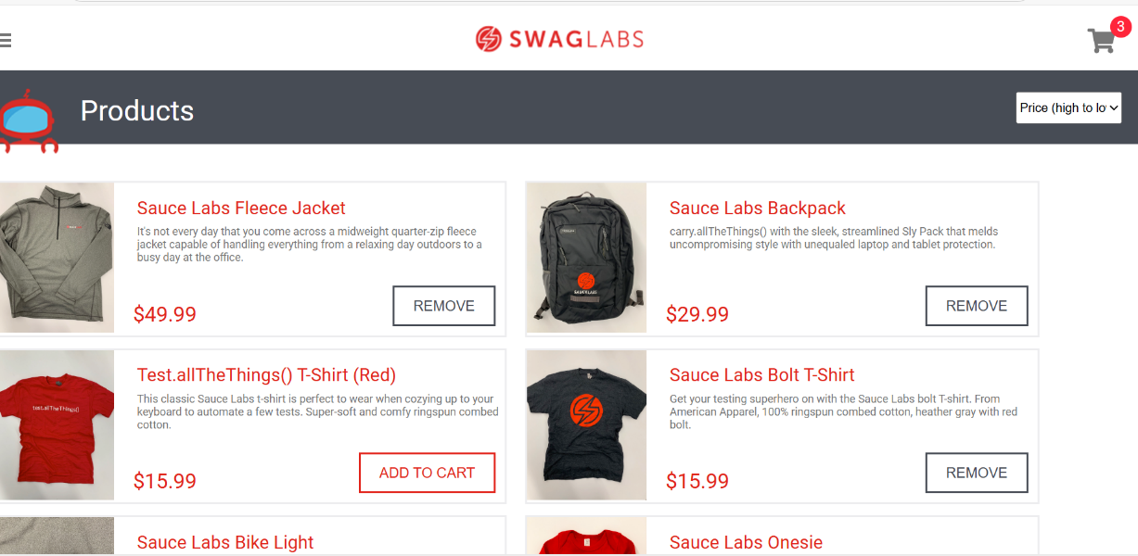

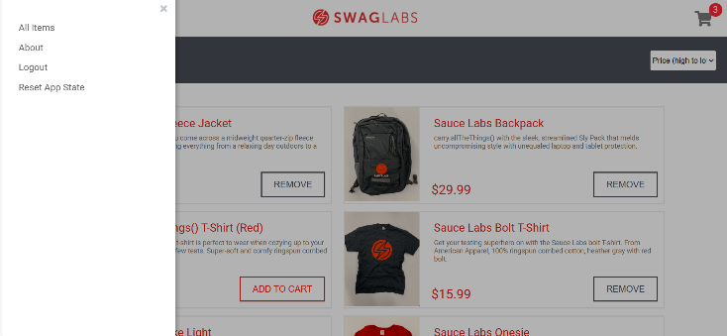 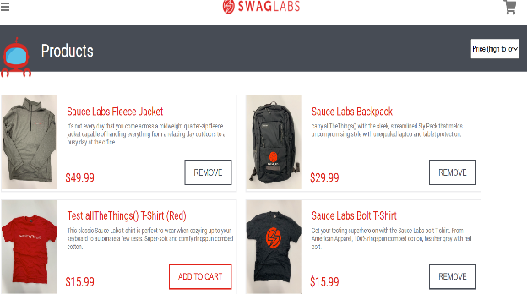

Result

* Expected: Sorting should return to default ("Name (A to Z)").
* Actual: Sorting does not return to default after reset.

**Priority:** low

**Severity:** low